5:02:06:01. General election. The general election ballot shall be white and shall be in the following form, as applicable:

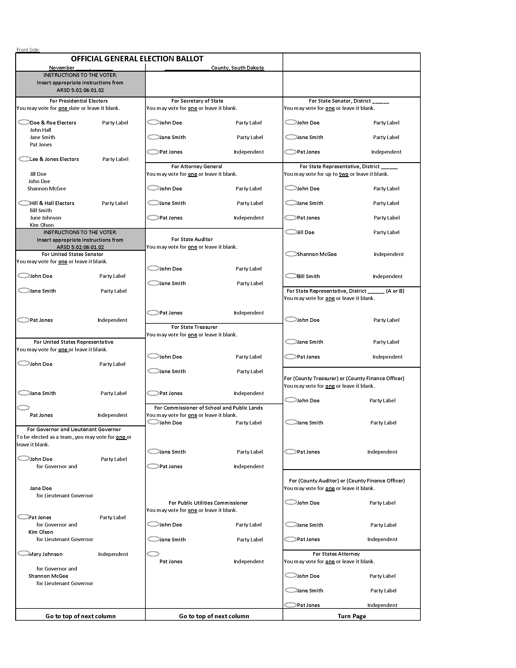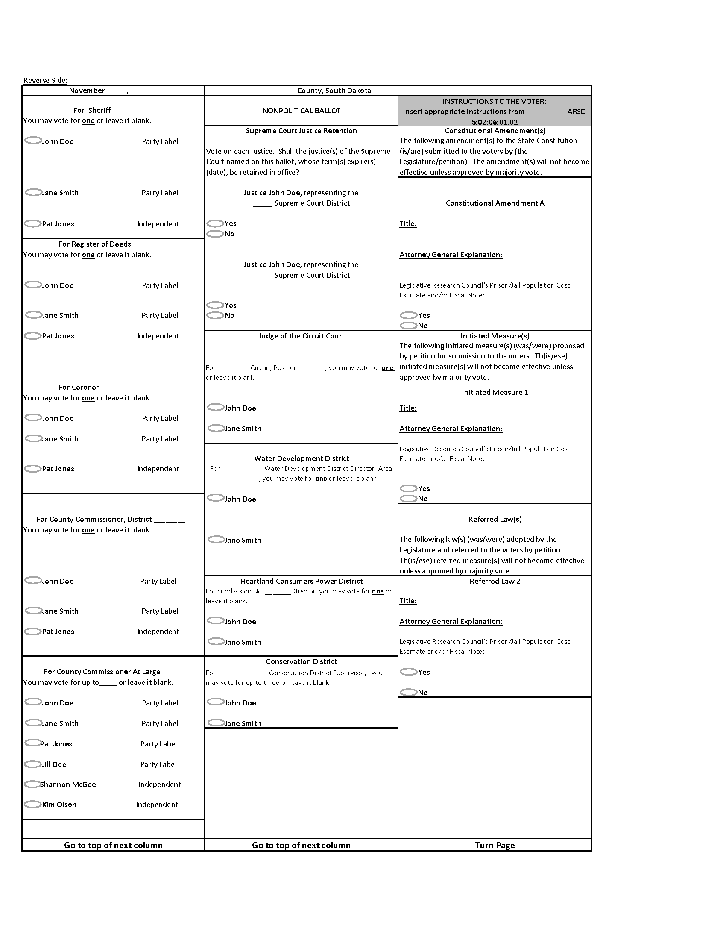

Printing note: The top right corner of the front side of each ballot must be cut off approximately one half inch from the right and top of the ballot. The person in charge of the election may select where to have the ballot stamp watermark printed on the ballot if the location is within the vendor's printing limitations.

Source: 2 SDR 5, effective July 30, 1975; 2 SDR 46, effective December 30, 1975; 6 SDR 25, effective September 24, 1979; 8 SDR 24, effective September 16, 1981; 12 SDR 43, effective September 23, 1985; 19 SDR 12, effective August 5, 1992; 22 SDR 95, effective January 18, 1996; 23 SDR 115, effective January 22, 1997; 23 SDR 236, effective July 17, 1997; 27 SDR 146, effective July 9, 2001; 28 SDR 99, effective January 17, 2002; 29 SDR 177, effective July 2, 2003; 33 SDR 230, effective July 1, 2007; 35 SDR 48, effective September 8, 2008; 36 SDR 209, effective June 30, 2010; 42 SDR 15, effective August 11, 2015; 42 SDR 178, effective July 1, 2016; 44 SDR 94, effective December 4, 2017.
General Authority: SDCL 12-1-9(2).
Law Implemented: SDCL 12-13-9, 12-13-25.1, 12-16-2.1, 12-16-9, 12-16-10.

