5:02:06:10. Primary ballot. The primary election ballot must have a blue indicator for the Democratic Party, white for the Republican Party, and a different color as certified by the Secretary of State for any other party. The ballot must be in one of the following forms, as applicable:

Hand counted paper ballots may only be used if there is no federal race on the ballot and must be in the following form, as applicable:

______________ PARTY
OFFICIAL PRIMARY ELECTION BALLOT
____________ COUNTY, SOUTH DAKOTA
JUNE ________, ______

To vote use a cross (X) or a check mark (ü) in the square in front of the name. DO NOT cast more votes than are allowed in each race.

For Governor, you may vote for one or leave it blank
□ _____________________
□ _____________________

For State Senator, District ____, you may vote for one or leave it blank
□ _____________________
□ _____________________

For State Representative, District ____, (you may vote for up to two or leave it blank) or (you may vote for one or leave it blank)
□ _____________________
□ _____________________

For State Representative, District ____ (A or B), (you may vote for up to two or leave it blank) or (you may vote for one or leave it blank)
□ _____________________
□ _____________________

For (County Treasurer) or (County Finance Officer), you may vote for one or leave it blank
□ _____________________
□ _____________________

For (County Auditor) or (County Finance Officer), you may vote for one or leave it blank
□ _____________________
□ _____________________

For States Attorney, you may vote for one or leave it blank
□ _____________________
□ _____________________

For Sheriff, you may vote for one or leave it blank
□ _____________________
□ _____________________

For Register of Deeds, you may vote for one or leave it blank
□ _____________________
□ _____________________

For Coroner, you may vote for one or leave it blank
□ _____________________
□ _____________________

For County Commissioner, District ____, you may vote for one or leave it blank
□ _____________________
□ _____________________

For County Commissioner at Large, you may vote for up to _____ or leave it blank
□ _____________________
□ _____________________

For Delegates to State Convention, you may vote for up to _____ or leave it blank
□ _____________________
□ _____________________

For Precinct Committeeman, you may vote for one or leave it blank
□ _____________________
□ _____________________

For Precinct Committeewoman, you may vote for one or leave it blank
□ _____________________
□ _____________________

If there is a federal race on the ballot, an optical scan ballot must be used and in the following format, as applicable:

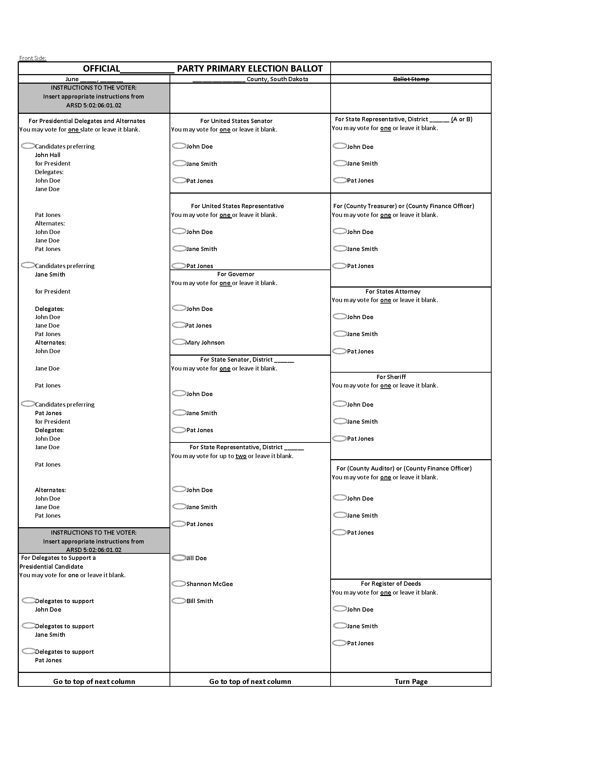

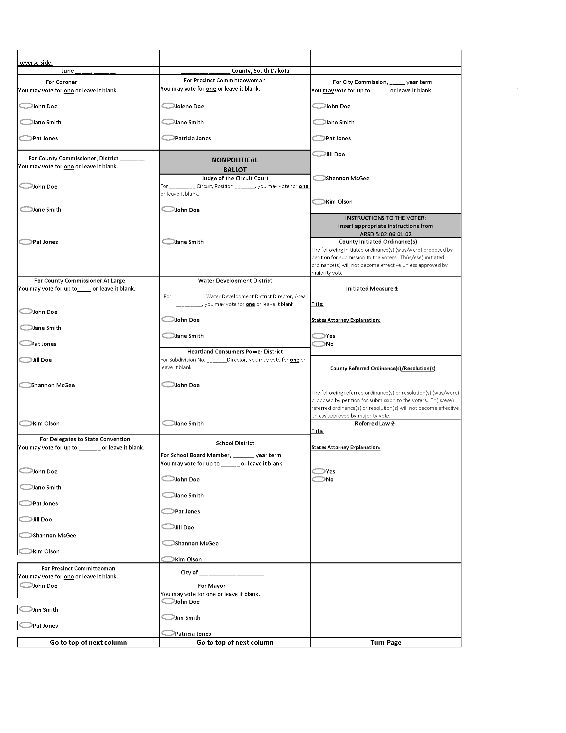

Printing note: For county commissioners at large or delegates to state convention, use the correct number designations for the number of candidates to be elected. For state representative, use the correct "vote for" phrase for the number to be elected. The top right corner of the front side of each ballot must be cut off approximately one half inch from the right and top of the ballot. The person in charge of the election may select where to have the ballot stamp watermark printed on the ballot if the location is within the vendor's printing limitations.

If a municipality, school district, or other local jurisdiction has a local ballot measure and the jurisdiction combines with the primary election, that ballot measure must be included on the county ballot and must follow the administrative rule for the layout of that specific ballot measure.

Source: 2 SDR 46, effective December 30, 1975; 4 SDR 85, effective June 14, 1978; 5 SDR 31, effective November 1, 1978; 6 SDR 25, effective September 24, 1979; 8 SDR 31, effective October 1, 1981; 10 SDR 27, effective September 26, 1983; 14 SDR 19, effective August 9, 1987; 16 SDR 20, effective August 10, 1987; 23 SDR 115, effective January 22, 1997; 23 SDR 236, effective July 17, 1997; 25 SDR 8, effective August 3, 1998; 27 SDR 146, effective July 9, 2001; 28 SDR 99, effective January 17, 2002; 29 SDR 177, effective July 2, 2003; 32 SDR 225, effective July 3, 2006; 35 SDR 48, effective September 8, 2008; 36 SDR 209, effective June 30, 2010; 42 SDR 178, effective July 1, 2016; 44 SDR 94, effective December 4, 2017.
General Authority: SDCL 12-1-9(2).
Law Implemented: SDCL 12-6-14, 12-16-2.1, 12-5-3.11.

